**STRUCTURES**

Lab Exercise # 7

Submitted by:**Sumalinog, Ethan Chav Isaac P.**

Submitted to:**Mr. Nasvin Del Rosario**

**Challenge:**

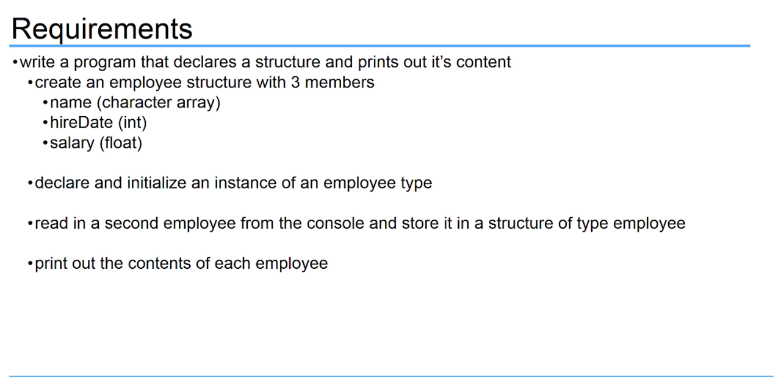

**Solution:**

I first created a *structure employee* data type with the 3 members: *char name[50], int hireDate* and *float salary*. In the *int main(),* I first declared the *structure employee* *one* and initialized its details(see code below for details). Next, I declared another *struct employee* data type named *two* and it asks for an input for the 2nd employee’s name, hireDate and salary that stores the information for the 2nd struct employee data type. The code ends with a printf’s that gives out the details of the 2 employees.

**Code:**

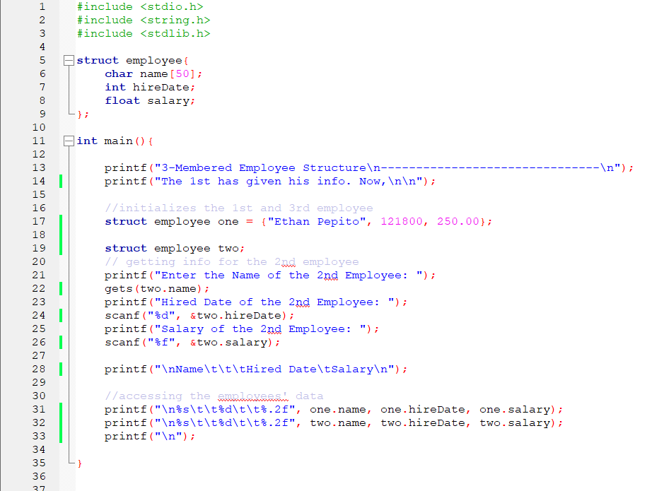

**Output:**

Notes for “Hired Date”:

* The date is in the format of month_day_year (There are no spaces in between the numbers).
* For the months, it can be: 1, 2, 3, 4,…,12. There is no “0” in before the single-digit month (1 to 9).
* For days, there is a “0” before single digit numbers.
* For years, only the last 2 digits are inputted.

Examples:

* December 18,2000 would be 121800 (12_18_00).
* August 15, 2001 would be 81501 (8_15_01).
* January 1, 1999 would be 10199 (1_01_99).

